# Task 1:

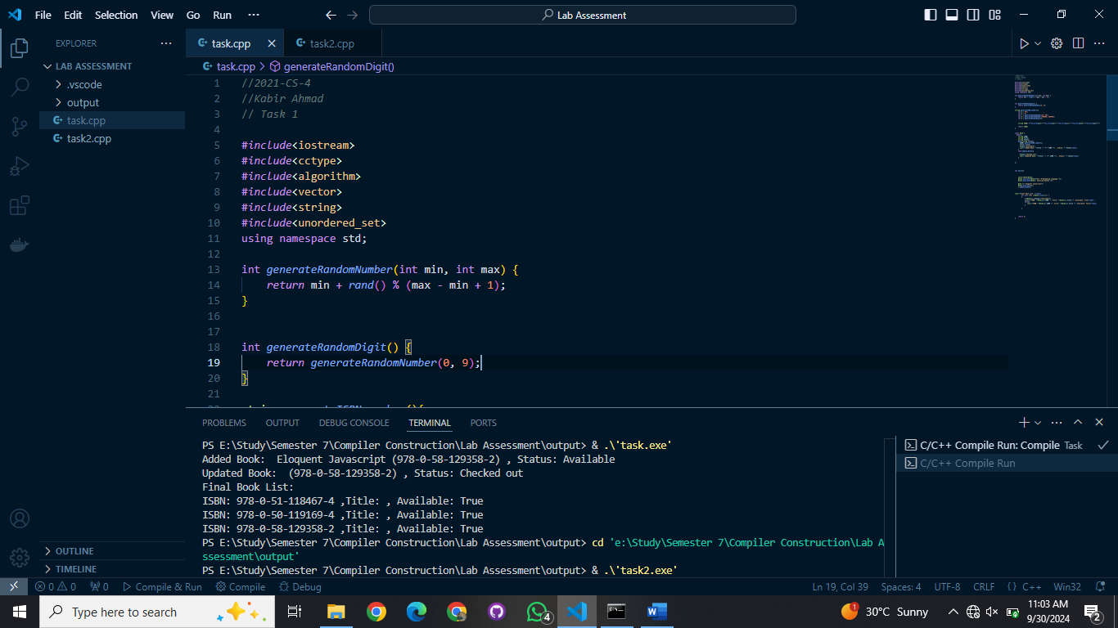

# Task 2:

